# 

# **Genetic Design Glowing GFP Kit**

# 

# TheO.png

# 

# **Introduction:**

Genetic design involves modifying an organism’s DNA to deliberately change an aspect of the organism for a particular purpose. This kit demonstrates the power and simplicity of genetic design by adding a gene to the **non-hazardous**bacteria so that it glows fluorescently with a Jellyfish gene.

This kit requires ~3 hours of work over the course of at least 2 days. It can be completed in a weekend if fresh bacterial cultures are prepared on a **Friday night**.

As this document is constantly being updated with tips and pointers and there are video links embedded, you can find the most up to date version online at: <https://goo.gl/qYhyvD>

# **What is happening in this experiment?**

Bacteria and all organisms need to make proteins to survive. Proteins are tiny nanomachines that do everything from control our metabolism to keeping our heart beating. In order to make a protein a cell uses the DNA code. Each 3 letters of DNA codes for a single amino acid and proteins are just chains of amino acids. This kit contains DNA with a gene that codes for the Jellyfish GFP protein. This protein fluoresces and glows when you shine blue light on it. We will insert the DNA into some bacteria, which is called bacterial transformation.

**Bacteria**

The bacteria used in this kit is called *Escherichia coli* (non-hazardous). This bacteria is commonly used in genetic design. Your **non-hazardous** form of *E. coli* has been optimized for taking up new genes.

**Plasmid**

A plasmid is a small piece of DNA that is connected in a circle. They usually only contain a few genes. These small DNA circles are easy to insert into bacteria. The plasmid supplied with this kit contains a gene to express the Jellyfish GFP protein.

## **Bacterial Transformation experiment:**

If you’d like, watch this video about *E. coli* transformation- it will help you understand how it works: <https://www.youtube.com/watch?v=vdY8uCQ84_4>

# protocoltableofcontents.png

# 

# Kit contents(pg. 3)

# 

# Timeline(pg. 4-5)

# 

# Making Plates[(pg. 6-8)](https://docs.google.com/document/d/1JMZmCDhzAtN2FSrjAbxP_FhRK90XbYpE0_PDvRYAKIQ/edit#heading=h.ekponrotise2)

# 

# Making Competent Bacteria[(pg. 9-12)](https://docs.google.com/document/d/1JMZmCDhzAtN2FSrjAbxP_FhRK90XbYpE0_PDvRYAKIQ/edit#heading=h.ekponrotise2)

# 

# DNA Transformation[(pg. 13)](https://docs.google.com/document/d/1JMZmCDhzAtN2FSrjAbxP_FhRK90XbYpE0_PDvRYAKIQ/edit#heading=h.ekponrotise2)

# 

# Successful experiment example[(pg. 14)](https://docs.google.com/document/d/1JMZmCDhzAtN2FSrjAbxP_FhRK90XbYpE0_PDvRYAKIQ/edit#heading=h.ekponrotise2)



1 - LB Agar

1 - LB Amp/IPTG Agar (Amp (100 µg/ml) and IPTG (120 µg/ml))

1 - 250 mL glass bottle for pouring plates

7- Petri Plates

Inoculation Loops / Plate spreader

Pairs of Nitrile Gloves in plastic bag

6 - 1.5mL microfuge tubes containing LB broth

50mL centrifuge tube for measuring liquid volume

5 - 0.1 mL bacterial transformation buffer (25mM CaCl2, 10% PEG 8000)

**Perishables**

Non-pathogenic *E. coli* bacteria (DH5ɑ)

5 - 50uL of 20ng/uL Jellyfish GFP plasmid



**Preparation**

* Sterility is an important factor for a successful experiment. Use isopropyl alcohol (rubbing alcohol found at your drug store) to sterilize your hands, gloves, surfaces, and inoculation loops before performing the experiment
* 1 hour Make plates (set aside more time if it's your first time making plates)
* streak out bacteria onto an LB Agar plate (takes ~1 min)
* 12-18 hours Let the bacteria grow (easiest to just let it sit overnight)

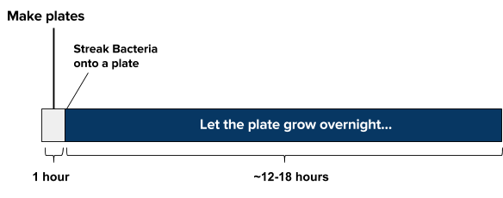

**Day of experiment**

* Mix together sample, plasmids, and transformation mix (takes ~5 min)
* **30 min** refrigerate sample solution (do NOT freeze)
* **30 seconds** ‘heat shock’ the sample warm (42ºC/108ºF) water. Add cell solution to your LB media. (takes ~1 min) incubate for at least 1-2 hours at 37C, (or if at room temp, incubate for at least 4 hours for best results) Plate a few drops of the bacteria solution and let dry for 10 minutes.

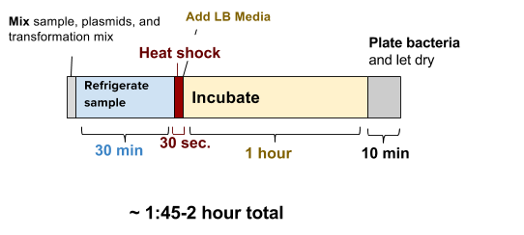



**Incubate and wait for growth**

* ~24 hours Incubate the plate at 37ºC (99ºF) for 16-24 hours or room temperature for 24-48
* hours.



# 

# 

# 

# 

# **Bacteria in this kit are non-hazardous and non-pathogenic (cannot cause disease). You can dispose of them by putting 5% bleach on the plate and then putting them in the trash.**

# 

# **protocolandwalkthrough.png**

# **Making Plates (~1 hour, maybe more time if it’s your first time)**

Step by step walk-through with photos at:<https://goo.gl/7yzpA1>

Agar plates provide a solid media nutrient source for bacteria and yeast to grow on. The standard media that is used is LB (Luria Broth, Lysogeny Broth, or Luria Bertani Broth). This contains a carbon source, a nitrogen source, and salt (many strains of bacteria like salt!).

The top part of the full plate has the larger diameter.

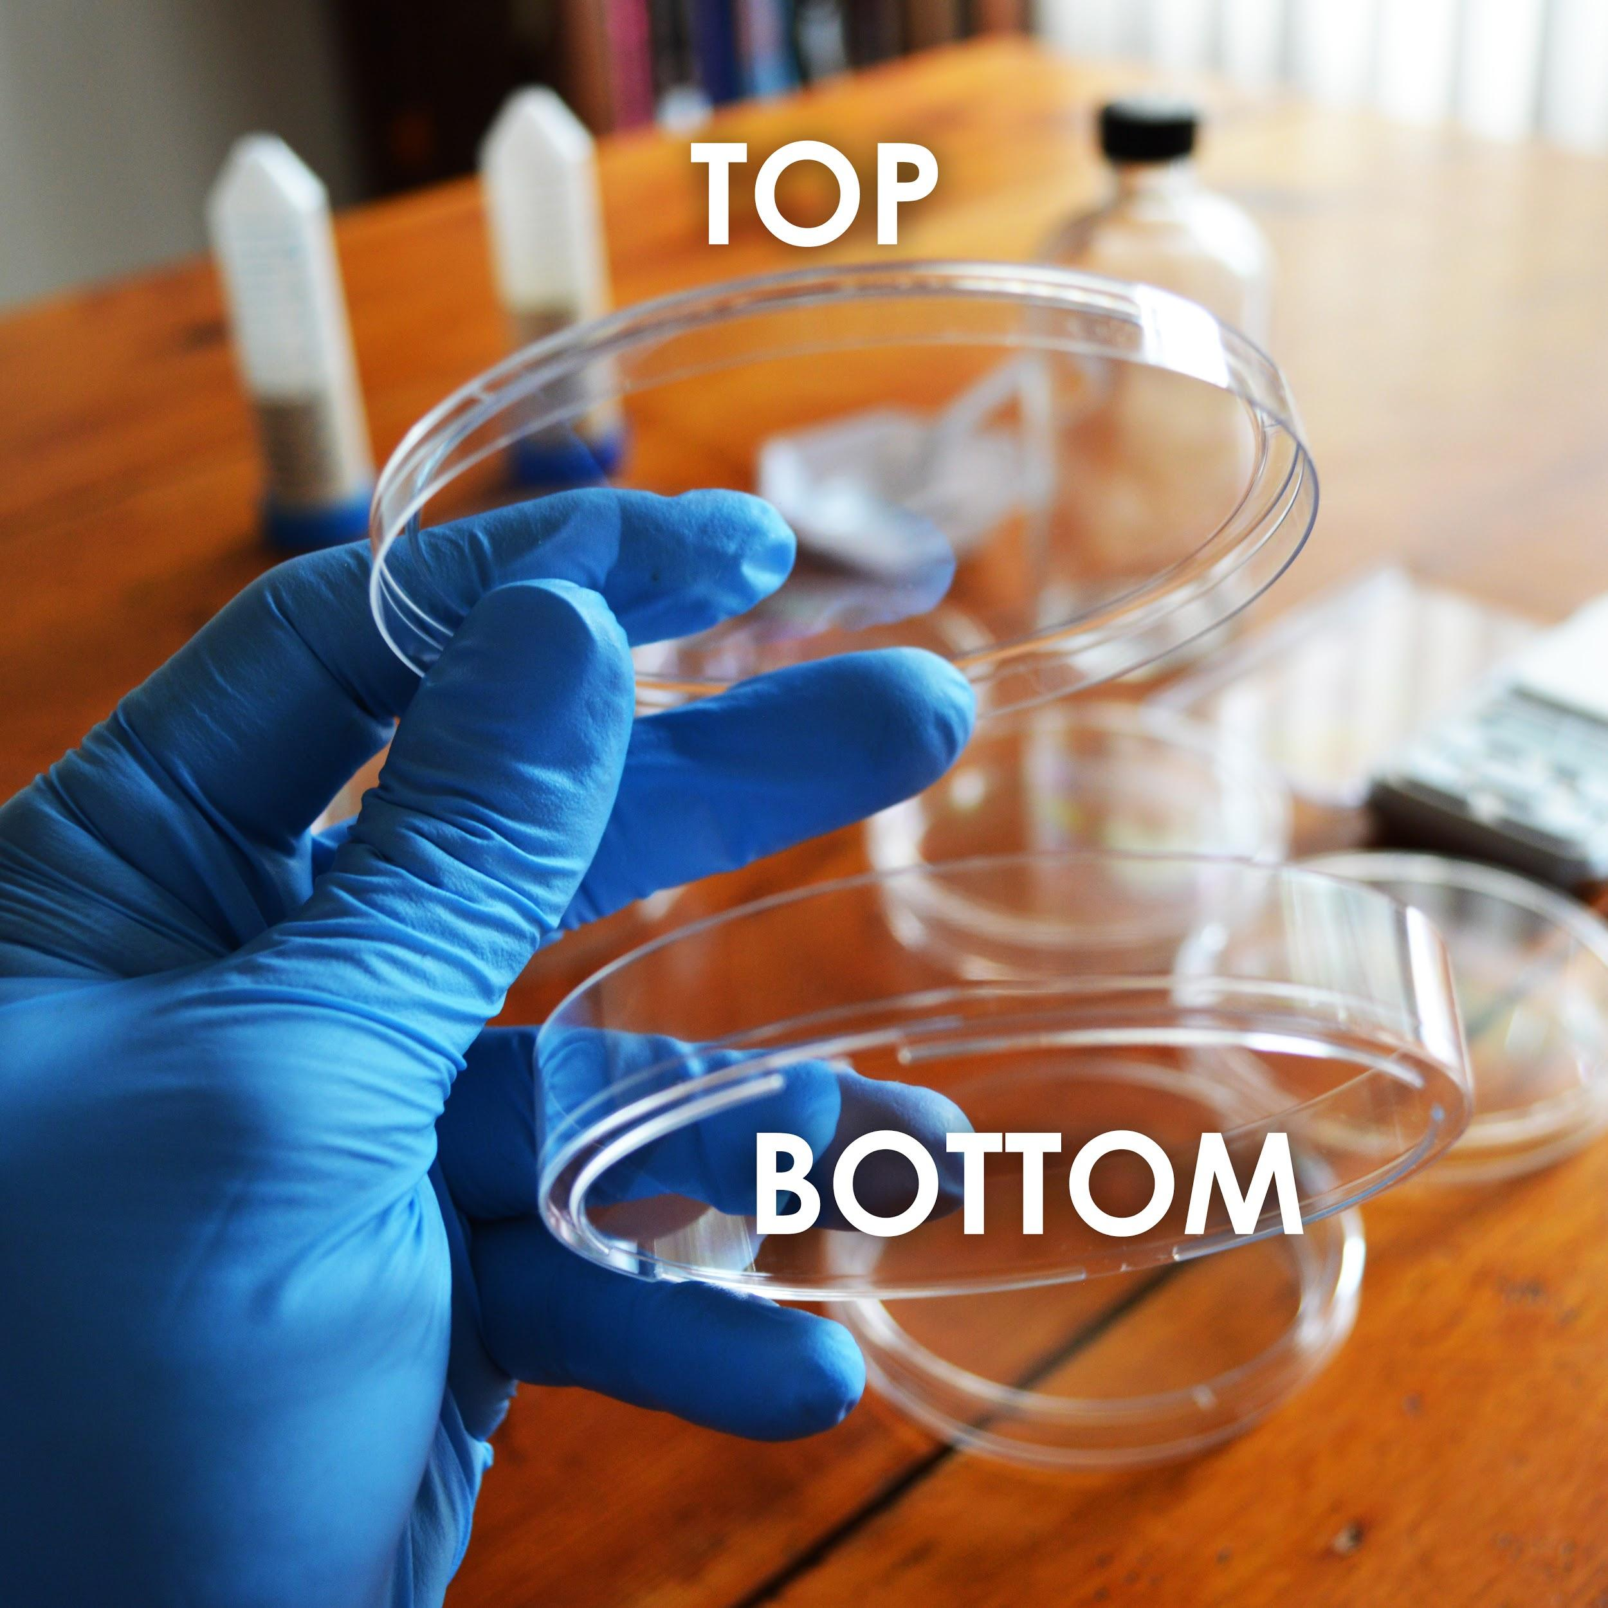



**Making Plates**

1. Take tube labeled “LB Agar Media” and dump its contents into the 250mL glass bottle.
2. Using the 50mL conical tube labelled “For Measuring Water”, measure and add 150mL of water to the glass bottle.
3. Making agar is like making jello-- heat the agar to dissolve it, then it will solidify when it cools. Heat the bottle in the microwave for 30 seconds at a time, being careful not to let the bottle boil over. DO NOT SCREW THE LID DOWN TIGHT! (just place it on top and give it a slight turn)
4. You will know it’s done when the liquid looks yellow.. This should take about 2 -3 minutes total of microwaving. Take the bottle out(caution contents hot) and let it cool until you are able to touch it without much discomfort. This will take 20-30 minutes.
5. While the bottle remains somewhat warm, pour the plates. One at a time, remove the lid of **two** plates and pour enough of the LB agar from the bottle to cover the bottom half of the plate. Put the lid back on. You will have plenty of LB agar media left over, but save 5 plates for the other media in the kit.

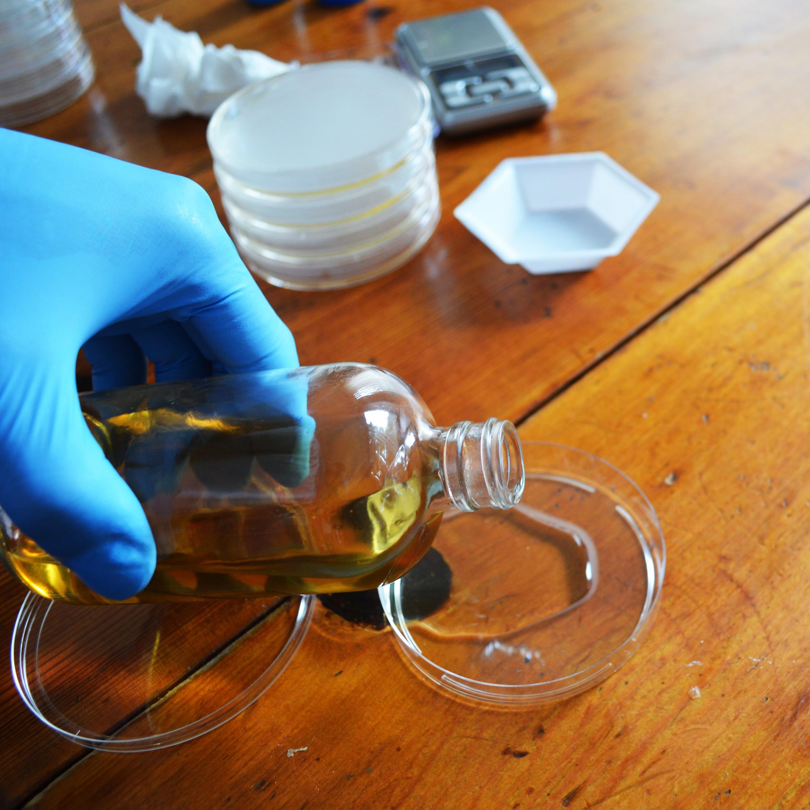



**Making Plates**

1. Let cool for at least one 1 hour before use (you can cool faster by putting them in the fridge but don’t freeze). If possible let the plates sit out for a couple hours or overnight to let the condensation evaporate. **Label these plates as “LB”**. Then store in your fridge at 4ºC upside down so any condensation doesn’t drip on the plates.
2. Repeat this process with the tube labeled “LB Amp/IPTG Agar Media” with the remaining 5 plates and **label these plates as “LB/Amp/IPTG”** (For final growth test). **NOTE: Only add 100ml of water into the 15ml tube on this media.**

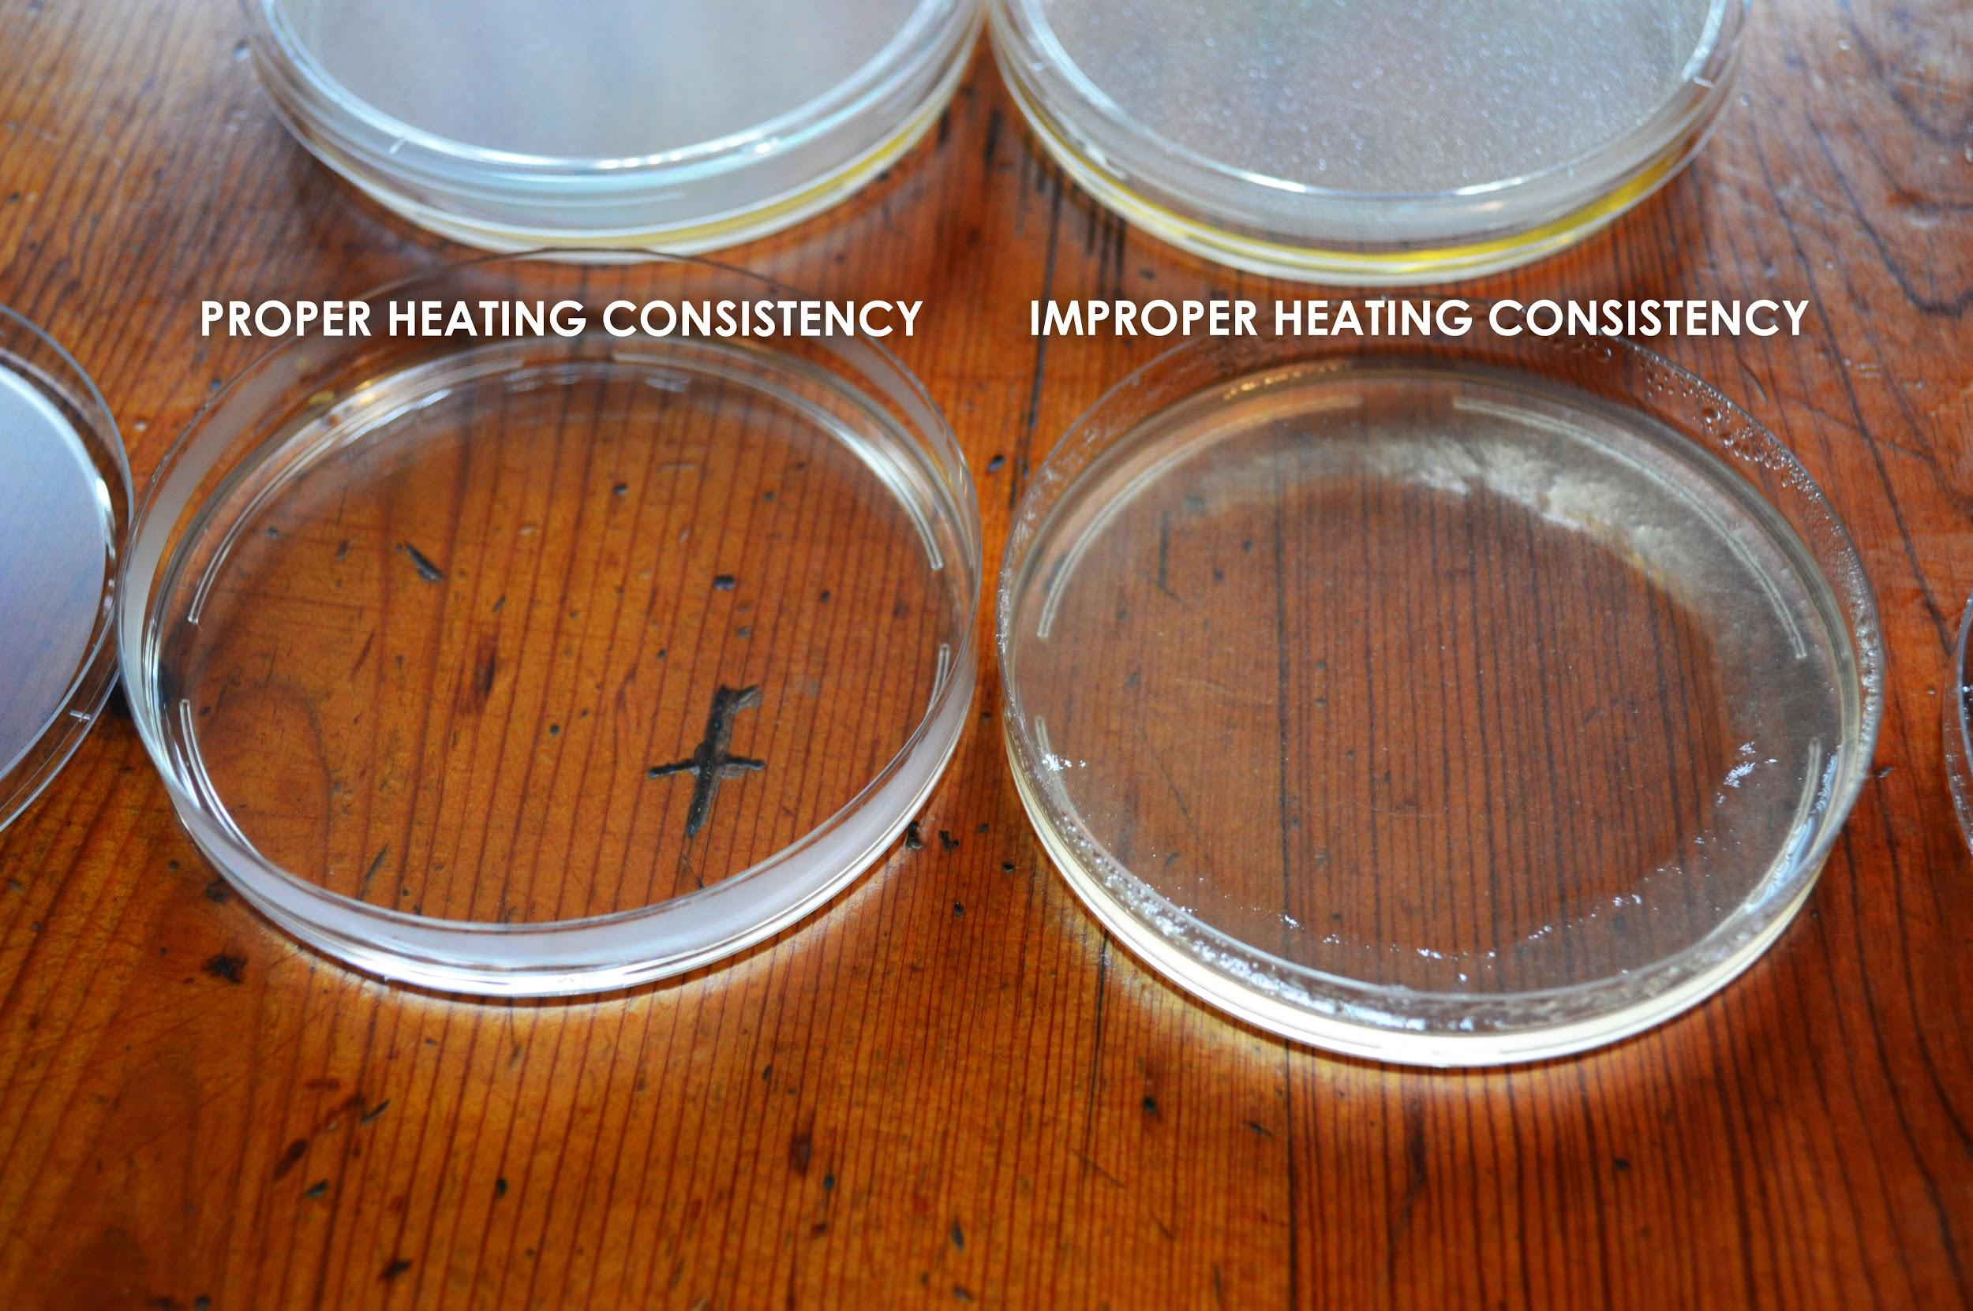

## 

## **protocolandwalkthrough.png**

## **Making Competent Bacterial Cells for Transformation**

‘Competent’ means the bacteria cells are able to intake foreign DNA. The cells’ walls *normally* prevent things from entering in, but we are going to mix the bacteria with chemicals and salts that change this. In order to get the genes to work we need to get them inside the cells! This process is called ‘transformation.’ We put all the materials into synthetic DNA and then trick the bacteria into thinking that our DNA is its own DNA, and so they make the proteins coded into the genes you put in DNA.

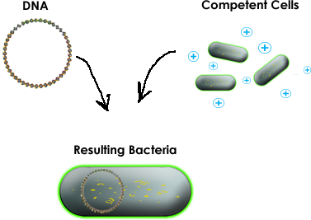



## **Making Competent Bacterial Cells for Transformation**

An agar stab is when someone takes an inoculation loop, puts bacteria on it and then stabs it into a tube full of agar. This method and process is used because it allows easy and safe longer-term storage as compared to a plate.

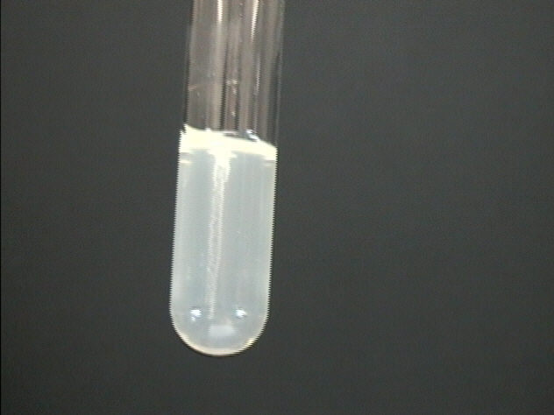

This is a picture of a stab. In your stab you should see a similar whitish line in the middle of the tube that contains bacterial growth. If you are having a hard time seeing the stab hold it up to the light.

In order to access the bacteria, use an inoculation loop and try and stick it along the same line as the stab. Then take the loop and gently streak it along a plate or use it to make a liquid culture.



## **Making Competent Bacterial Cells for Transformation**

1. Use an inoculating loop to gently scrape out some bacteria and spread it onto a new “**LB**” plate. Let the plate grow overnight ~12-18 hours, or until you see white-ish bacteria begin to grow. Make sure you are using the LB agar plate, NOT the LB/Amp/IPTG agar plate. See the following link for a walk-through of how to streak out bacteria:<https://goo.gl/GR8IOf>
   1. Note: avoid placing the plate in areas that are cold or the bacteria will grow slowly. Consistent and warm temp. locations are preferable.
   2. Your bacterial plate can be stored in the fridge for a week. However, having fresh bacteria for a transformation greatly increases the likelihood that your experiment will work.

## streakbacteria.jpg

## 

## 

## 

## **protocolandwalkthrough.png**

## **Making Competent Cells for Transformation(continued)**

1. Using an inoculation loop, gently scrape some bacteria off of your fresh plate until the loop is filled, and mix it into one of the “bacterial transformation buffer” tubes. Mix until any big clumps have disappeared. This might require gently sucking the mixture up and down using a transfer pipette. Your transformation mix should be very cloudy, if not repeat the first step until the liquid turns hazy but not quite opaque in the tube. You can store these competent cells at 4ºC (39ºF) in the fridge for 1-2 days if you are not immediately performing the experiment. We suggest attempting one experiment at a time which gives you multiple opportunities to repeat the experiment.

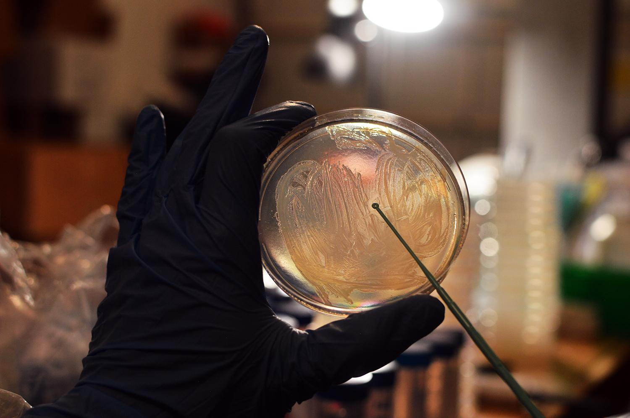



## **DNA Transformation**

(Force DNA droplets to bottom of tube by holding closed cap end and flick wrist and elbow)

1. Find a tube labelled “plasmid”. Using your pipette, add its contents to the competent cell mixture.
2. Incubate this tube in the fridge or on ice (DO NOT FREEZE) for 30 minutes.
3. Incubate the tube for 30 seconds in 42ºC (108ºF) water. You can approximate this temperature by using water that is warm, but comfortable enough such that you can still keep you hand in it.
4. Using a pipette, fill one of the LB powder microcentrifuge tubes almost full of room temperature water, leaving room to shake and dissolve the LB.
5. Using the same pipette, add about **half** of your LB media from the microcentrifuge tube to your competent cell mixture containing your DNA, and mix gently by flicking the closed tube.
6. Incubate the tube at 37C(99F) for 2 hour or 4 hours at room temperature. This step allows to bacteria to recover and replicate the inserted DNA. **DON’T** skimp on the time, this step is key for the experiment to work. If you are having trouble with your experiment increasing this incubation time up to 12 hours will increase the chances of experimental success. Take a LB/Amp/IPTG plate out of the fridge and let it warm up to room temperature.
7. Using a pipette, mix and then add about 4-5 drops of your transformation mixture on top of an LB/Amp/IPTG agar plate.
8. Using an inoculation loop or the spreader, gently spread the bacteria around the plate and let dry for 10 minutes before putting the lid back on.
9. Flip the plate upside down to prevent condensation from forming and dripping onto your bacteria.
10. Incubate the plate at room temperature for 24-48 hours **or** 37ºC (99ºF) for 16-24 hours.
11. Once you see little white round dots forming put on your glasses and shine the blue light on the plate. The glasses help block the blue light so you can see the flourescence of the Jellyfish GFP protein in the bacterial cells. If not, give it another shot. Science doesn’t always work on the first try. Also, feel free to contact us at odin@the-odin.com and we will help you troubleshoot.

## **Successful experiment example...**

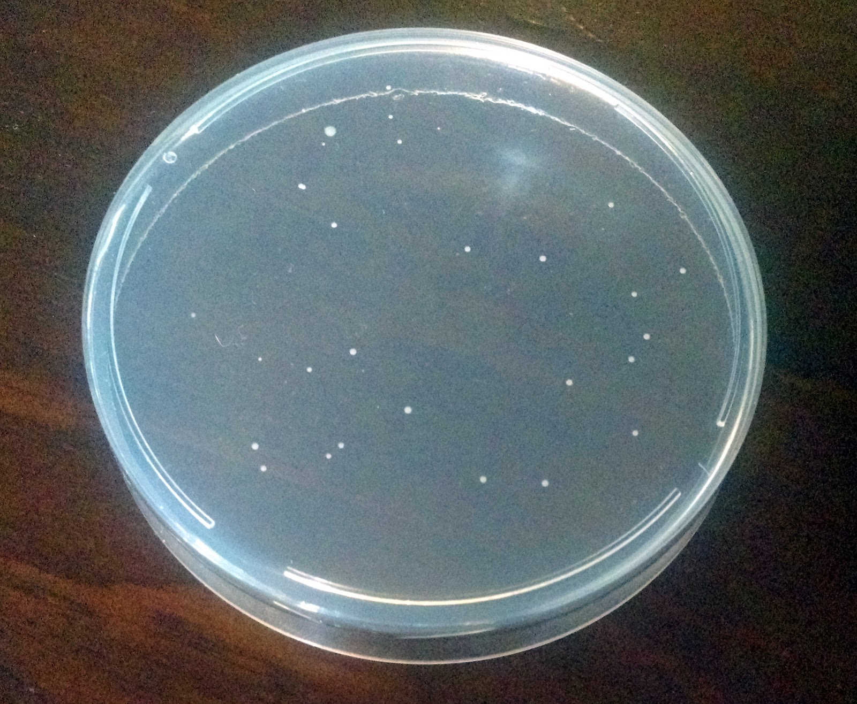

In a successful experiment you should see white bacteria growing on the plate when not using a blue light and glasses. Using the blue light and glasses to see the bacteria glow green. These are bacteria that were successfully edited and so they survived and replicate to form what scientists call colonies, or small groups of bacteria.

Using the Transformed Bacteria to make art:

Once you have successfully transformed the bacteria to express the GFP plasmid. Use a clean inoculation loop to streak out the bacteria onto a fresh plate of LB IPTG agar plate with your own design! Allow 1 day for your bacteria to grow on the plate and once you are happy with the design use the provided acrylic fluid to save it.

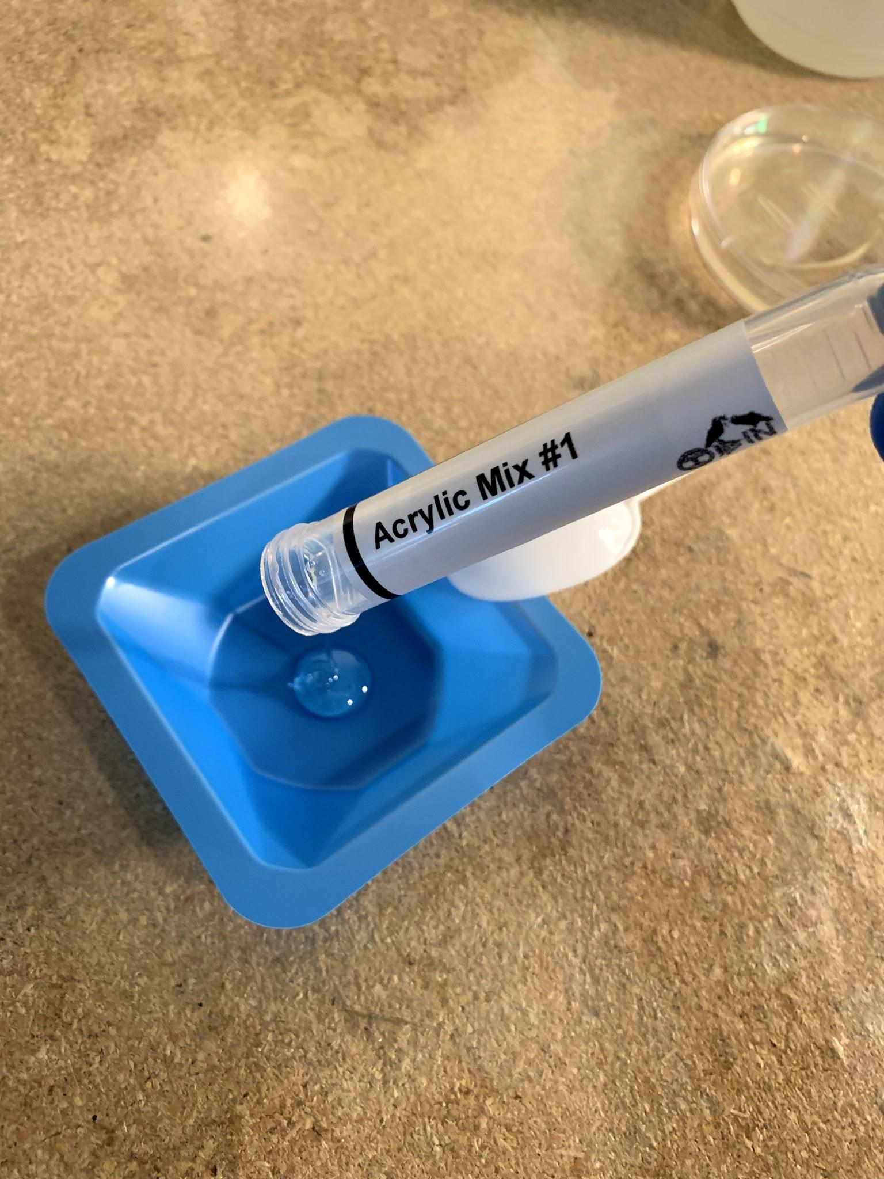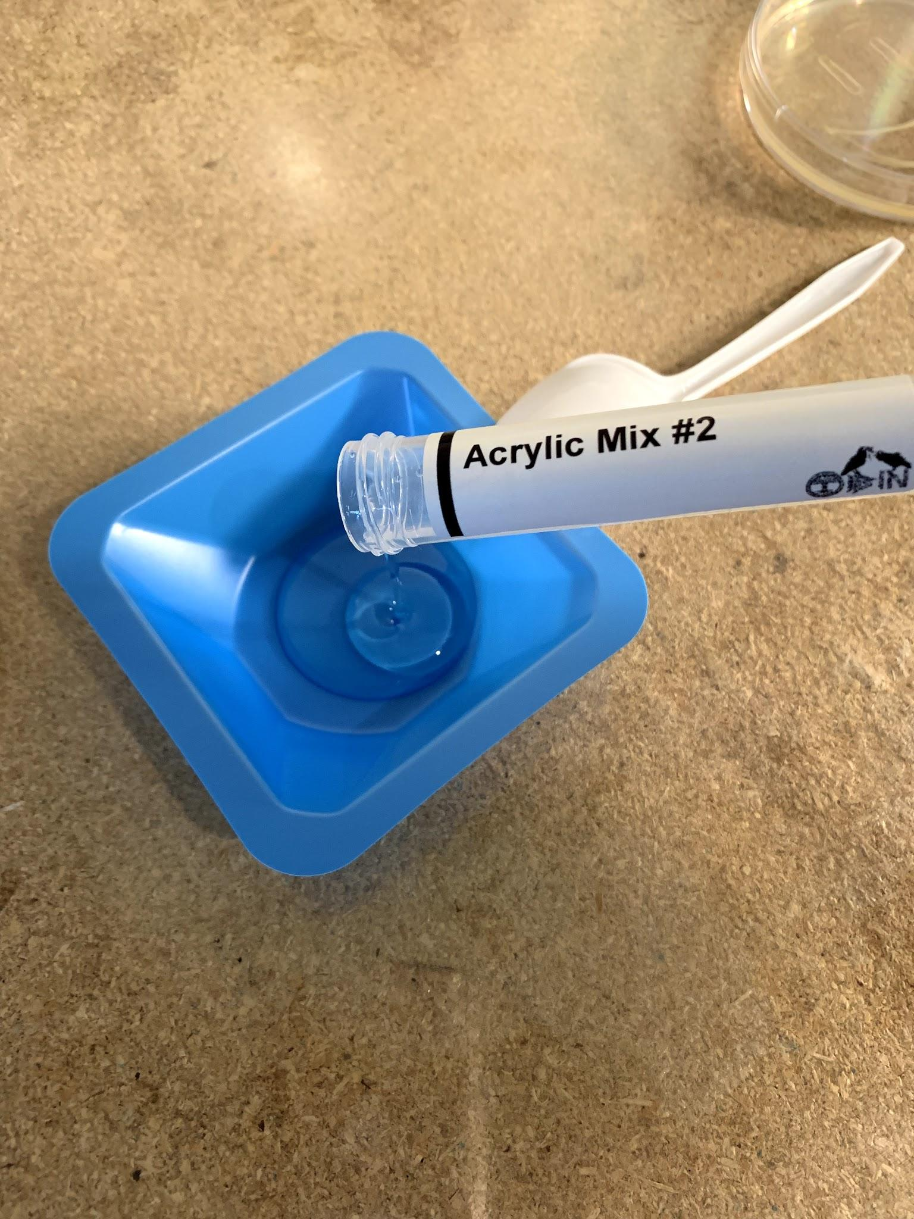

Create the Acrylic by combining the 2 provided tubes that are labeled Acrylic fluid 1 and 2 onto the provided weigh boat. Then using the plastic spoon mix the fluids thoroughly for 5 minutes then allow the mixture to sit for 5-10 minutes in order to remove the air bubbles. Pour the acrylic mixture onto the plate with your plate with the artwork. Allow the acrylic to harden on top of the plate.

*The Acrylic hardens with bubbles on top of it, to reduce the amount of bubbles allow the Acrylic mix to sit before pouring onto the agar plate*

Try our other kits:

**Genetically Engineer Any Brewing or Baking Yeast to Fluoresce**

[http://www.the-odin.com/genetically-engineer-any-brewing-or-baking-yeast-to-fluoresce](http://www.the-odin.com/genetically-engineer-any-brewing-or-baking-yeast-to-fluoresce/)

**Genetic Engineering Home Lab Kit**

<http://www.the-odin.com/genetic-engineering-home-lab-kit>

**Genetic Engineering CRISPR Lab Kit**

<http://www.the-odin.com/diy-crispr-kit/>